

Game Price Search Tool

Project Group Members: Ding Liao, Zest, Jason, Zhuoyan Liu

INFO 200 | AE Group 5 | Locksley Kolakowski

**Table of Contents**

**Solution Considered** 3

Solution 1: An extension tool 3

Solution 2: An Account on Existing Apps 3

Solution 3: A Game Journal 3

Solution 4: A Game Search Engine 4

**Selected Solution: A Game Search Engine** 5

**Solution Description** 5

**Product Features** 5

**Primary Features: Basic Information Display** 5

**Secondary Features: Related information regarding game** 5

**Low-Fidelity Wireframing Stage** 6

**Moodboard** 7

**Font** 8

**Colors** 9

**High-Fidelity Wireframes** 10

**Onboarding** 10

**Usage Scenario 1** 11

**Usage Scenario 2** 12

**User Journey Map** 13

**Interactive Prototype** 13

**References** 14

**Appendix** 14

# **Solution Considered**

## Solution 1: An extension tool

The first solution will be the extension tool on the game platform which allows users to compare the game prices, such as steam and origin. It is highly associated with the game platform itself. For the user using, it is automatically applied to the game platform. This extension tool will acquire data of game price on the respective game platform and compare with previous price and current price from other game platforms. The final output will be a list of games’ prices in order which is sorted out by its categories, game platforms, and magnitude. Extension tool of game price comparison is more easily installed and used which provides users with significant convenience.

## Solution 2: An Account on Existing Apps

The second solution will be a Tik Tok or twitter account which will post price changes, or any discount notice every day for different games. People who organize the account will check the price for the game regularly, then make graphs showing how the price fluctuates. This solution is good for people who do not want to download apps. It is convenient for the user who already downloaded the excited apps like Tik Tok or twitter since in order to know price changes they only need to follow this game price account in advance. This account can release price change messages fast since it only needs to type “DISCOUNT 20% for XXX” within seconds. And then the user will get notifications on their phone. However, it is bad for users who want to check or compare prices for similar games. The account will post messages regularly, but the account cannot organize for a long period. Also, it is hard for users to check since it always past the newest information for different games. If a user wants to check a game in the past it will cost lots of time.

## Solution 3: A Game Journal

Another possible solution is to create a Game Journal to record the prices of games on different platforms every week. This solution is good for people to study about the history prices of games. Also, people who buy these journals can use them as collections. However, it is not time sensitive. Journal buyers cannot get the information until they read the journal, which might lead people to make a bad decision on their thoughts. In addition, buying a journal does cost people some money. If one wants to save money through monitoring the price of games on different platforms or during different times, whether to pay for this information is a good question.

## Solution 4: A Game Search Engine

A search engine for games, which is similar to Google, Baidu, or any other search engine utilized for information seeking. Users can input a published game name, a game demo, a nickname, or game categories to discover materials they might desire. While a valid game name is imputed, information like basic description about this game will pop up. In addition, a statistical result analyzed from various websites such as Steam, Epic, SteamDB and GOG.com will also be there for price comparison as well as price prediction. There will also be a recommendation system to showcase games with similar topics or themes. What’s more, if one is not sure about a game’s information, such as its full name, a nickname or any other related searching keywords can be input to search; for instance, you could enter SE to look for games produced by Square Enix Holdings Co., Ltd. You can also type in stuff like “SF games with cooperation”, etc. The search result can be a focused material on your desired contents or a comprehensive list of potential materials that you might look for or even will become interested in.

|  |  |  |  |  |
| --- | --- | --- | --- | --- |
|  | Solution 1 | Solution 2 | Solution 3 | Solution 4 |
| Description | An extension tool of game price comparison which highly associated with game platforms | An account on existing apps | Record prices on a Game Journal | A Game Search Engine |
| Advantages | * Easily install * Clear to see and compare * More acceptable by crowds | * Do not need install * Fast notifications | * Good collection * Historical value | * Comprehensive Search Result * Powerful functionally * Easy to use |
| Disadvantages | * It is not individual application * It may encounter the problem of data accessing. * It needs to go through strict privacy policies. | * Hard to check past data * Hard to direct search for single game * Need consistent attention | * Not time sensitive * Subscribe costs money | * App/Website based, cannot cooperate with Game Platform’s client * Perform complex screen because of the comprehensively |

Table 1 Solution Considered

# **Selected Solution: A Game Search Engine**

A game search engine is easy to use and can produce a comprehensive result for the majority of the stakeholders. Stakeholders can always simply input a game name, a game demo, a nickname, or game categories to discover materials they might desire. Due to the modern digital age, people are used to utilize those search engines like Google and Baidu, thus implementing user interfaces similar to those technics would make more sense to more users as well as potential audiences. In addition, this application will be available to all platforms with further developing, just like every can google at any time with any devices through a web browser or an app. Therefore, comparing to the other three solutions, a search engine would be the best one to fit to our stakeholders as whole.

# **Solution Description**

## **Product Features**

### **Primary Features: Basic Information Display**

Feature 1: Game Information

Basic information of the game will be displayed if users enter a valid game name. Basic information includes game name, a game demo, a nickname, and game categories.

Feature 2: Statistical Analysis

Statistical analyzed data will be processed and output from various websites such as Steam, Epic, SteamDB and GOG.com. The price comparison of the game in different game platforms will be conducted as well as price trends and price prediction.

Feature 3: Recommendation system

There will also be a recommendation system to showcase games with similar topics or themes.

### **Secondary Features: Related information regarding game**

Feature 1: Related information searching

Users can search for information about a game to allow the system to generate exactly the game they are looking for. This feature can help not only heavy gamers, but also newcomers. New gamers can use this feature to find games they may need, as many heavy gamers prefer to use the nickname to refer to a game rather than the full name.

Feature 2: Content-focus

This feature helps players to find the games they need. Sometimes people prefer to play or compare games with similar content. This feature can help players who want to find games based on content.

# **Low-Fidelity Wireframing Stage**

Our first prototype receives quite good feedback. However, it does have drawbacks to provide a more comfortable interaction with users; for instance, although the chosen design style is cool, some texts can appear to be hard to recognize and read. We learn that a UI layout should not only look good but also make sense to its audiences. Therefore, we choose to change the font colors and provide a background color to the paragraphs, which can more clearly showcase the information as well as emphasize the important news.

In addition, our first interaction fails to produce a logical user journey map, where buttons messed up to show their functionalities. A button with a microphone vector illustration misleads users to think of it as a voice input function. However, we mean to design it to change the volume of the application. In addition, it makes no sense to always show this button in the very left bottom corner of all screens. We just initially think about designing this feature for those devices which don’t have an external button to control the volume. Therefore, we re-design this feature by adding a setting screen where users can configure their own options for those cool features.

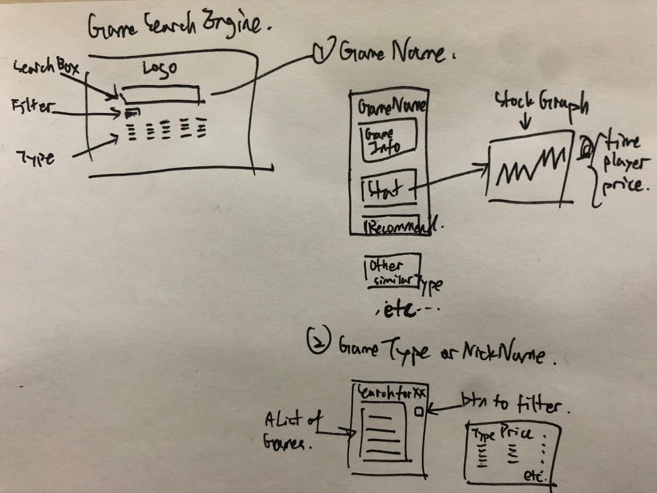

Figure 1 Product Design in Brainstorming Stage

# **Moodboard**

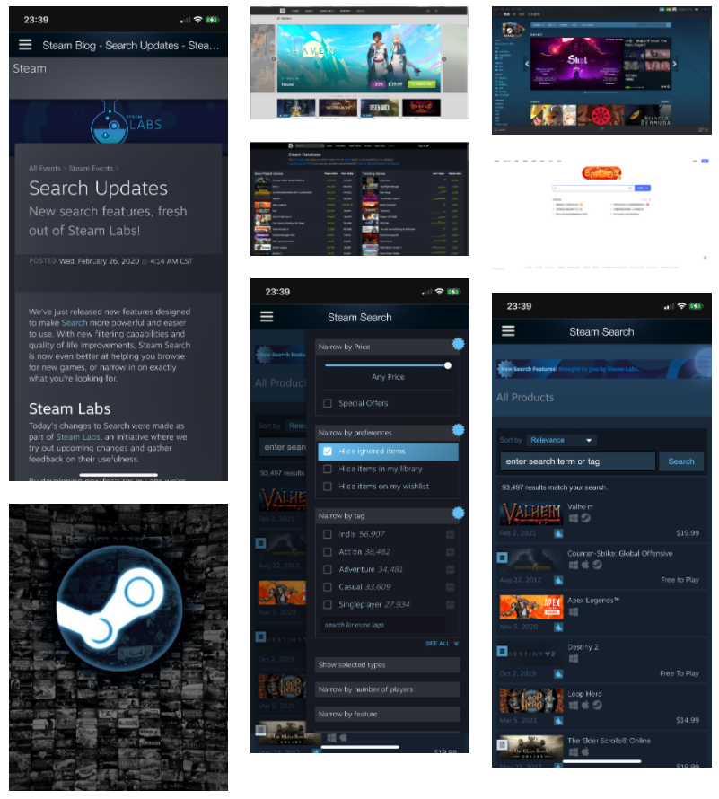

Figure 2 Moodboard Link: <http://www.gomoodboard.com/boards/zgybFGol/share>

## **Font**

The font we are using is “Roboto”. This font makes more sense for those audiences who are used to the electronic devices and interact with a great variety of applications, just like those who prefer “Time New Roman” fonts in academic papers and newspapers as well. The design fashion of this font is more commonly seen in various prevailing websites and forums.



Figure 3 Picture from Wikipedia: <https://en.wikipedia.org/wiki/Roboto#/media/File:Roboto_Font_Sample.svg>

## **Colors**

We choose to use a brown overall background with purple title texts and while paragraph texts of a grey filling background as our main color design style. This design would make the application to be more welcomed by those game players, who are used to the deep color design in their daily gaming usage. In addition, the contrast between brown and white would emphasize the contents of information, especially having a purple color design of titles. Users would be more likely to recognize the layout of information and thus discover the materials they are looking for.

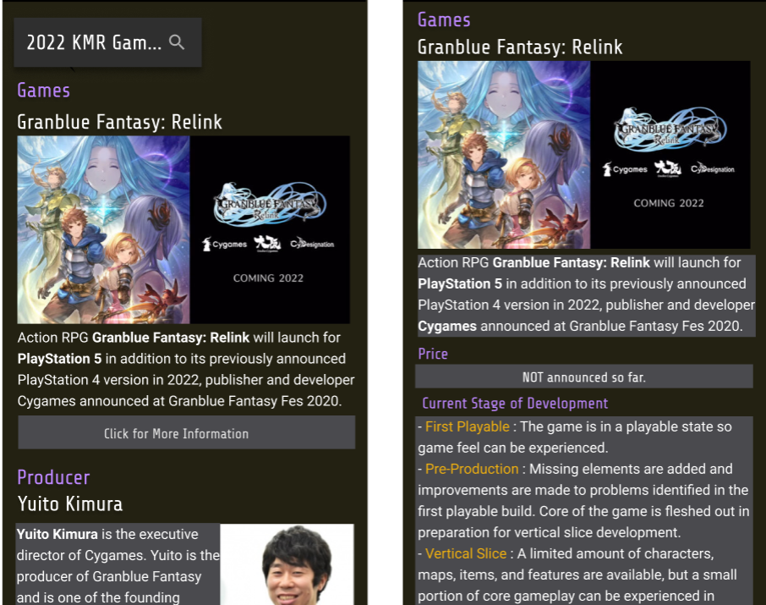

Figure 4 Prototype In-app screenshot

# **High-Fidelity Wireframes**

## **Onboarding**

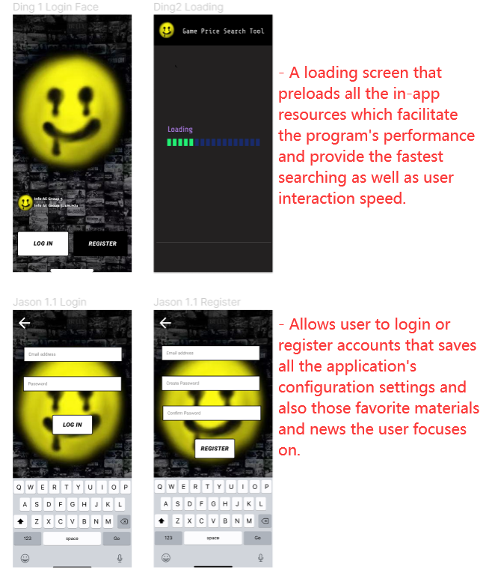

Figure 5 Prototype Onboarding Screen

## **Usage Scenario 1**

Log in, Loading, and Home Screen

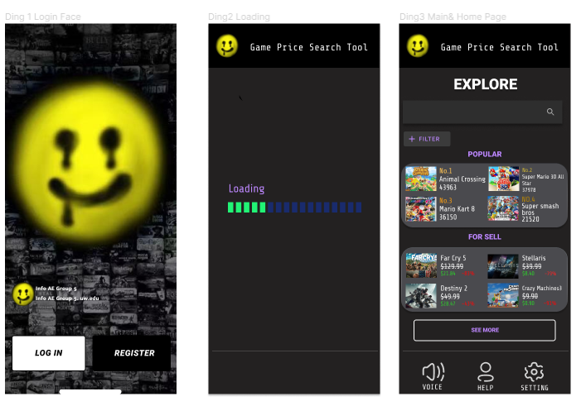

Figure 6 Prototype Log in, Loading, and Home Screen

The login page permits users to use different social media accounts, google accounts, or created GPST accounts to get access.

The loading page gave the flexibility of waiting for responses to pages or applications.

The home page contains a voice over function that can help people with disabilities to use our tool. The help button aside can help with users with any existing problems. Every user will be assigned with stuff that helps them respectively. The last button is a setting which can make changes of voice over and front size.

## **Usage Scenario 2**

Search Bar and Search Results

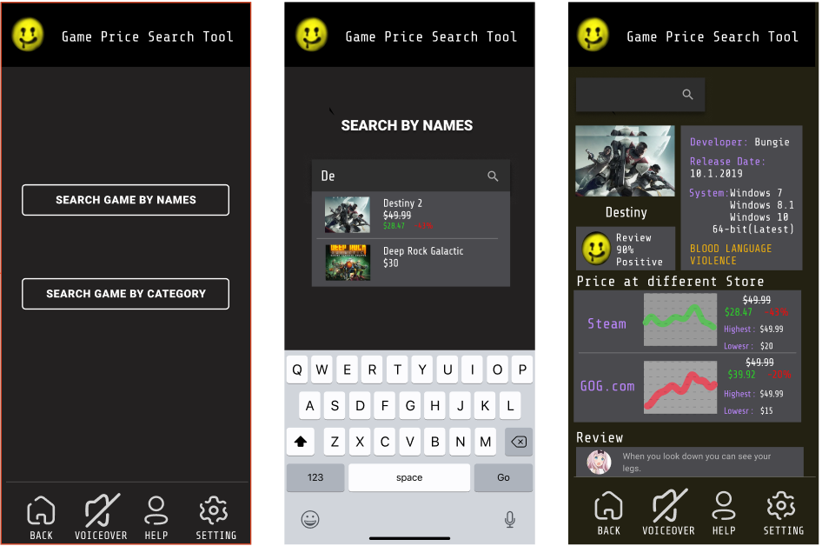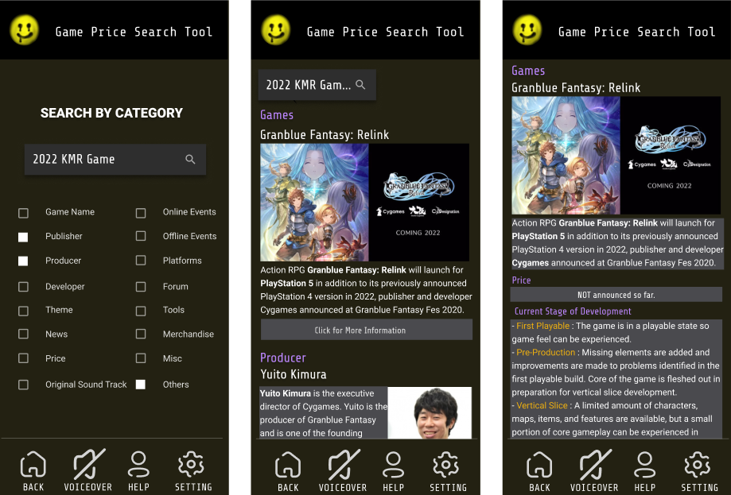

Figure 6 Prototype Search Bar and Search Results Screen

The main search page allows users to select the way they want to find their targets.

The Search by Names page depends more on users’ familiarity to a game, while Search by Category page does not.

Selecting a game will provide users not only the price condition, but also some extra information about their targeting games.

## **User Journey Map**

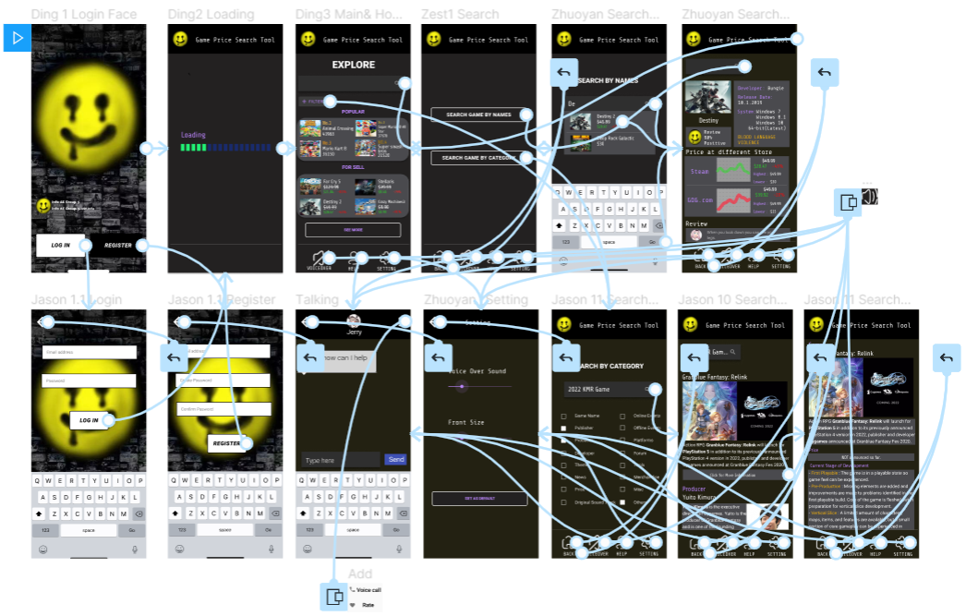

Figure 6 Prototype Journey Map in Figma

# **Interactive Prototype**

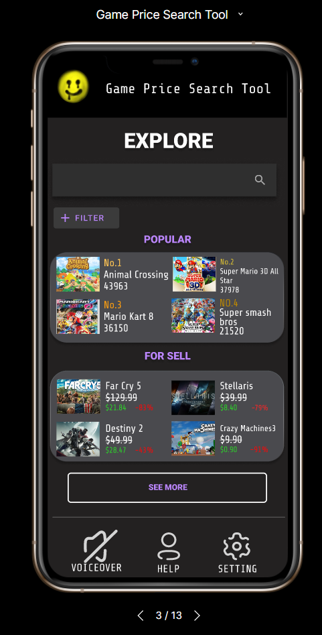

Please check our prototype made by Figma via the following link:

<https://www.figma.com/proto/VZUGUUPTGWNX1WUj9dL68I/Game-Price-Search-Tool?node-id=10%3A133&scaling=scale-down>

# **References**

GameDealsMeta. (2020). *GG.deals is no longer allowed.* Retrieved from Redidit: https://www.reddit.com/r/GameDealsMeta/comments/czp63f/ggdeals_is_no_longer_allowed/

*Law of Common Region*. (2021, 2 1). Retrieved from Laws of UX: https://lawsofux.com/laws/law-of-common-region/

*Law of Similarity*. (2021, 2 1). Retrieved from Laws of UX: https://lawsofux.com/laws/law-of-similarity/

*Law of Uniform Connectedness*. (2021, 2 1). Retrieved from Laws of UX: https://lawsofux.com/laws/law-of-uniform-connectedness/

*Miller’s Law*. (2021, 2 1). Retrieved from Laws of UX: https://lawsofux.com/laws/millers-law/

Minor, J. L. (2020 , 8 14). *GOG.om Review | PCMag*. Retrieved from PCMag: https://www.pcmag.com/reviews/gogcom-for-pc

*SteamDB - Community*. (2021, 2 14). Retrieved from Steam Community: https://steamcommunity.com/groups/SteamDB/announcements\

# **Appendix**

**Reference Images**

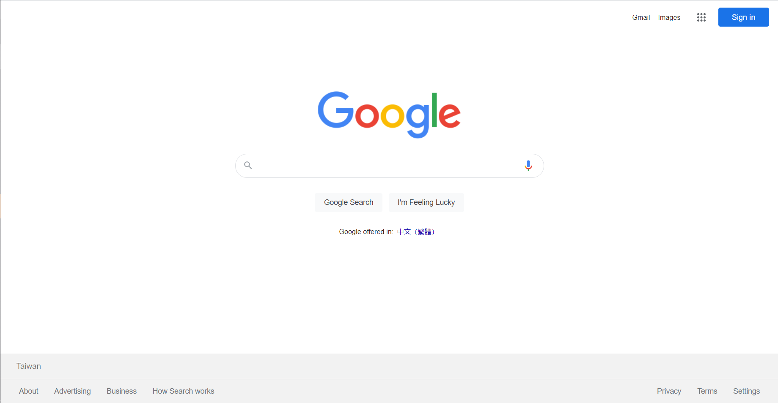

Figure 7 Reference Image Page: google.com

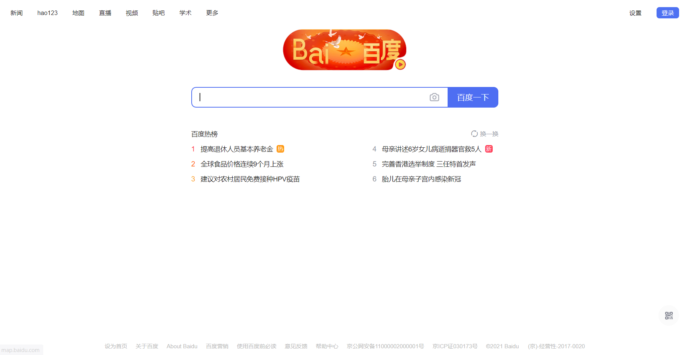

Figure 8 Reference Image Page: baidu.com

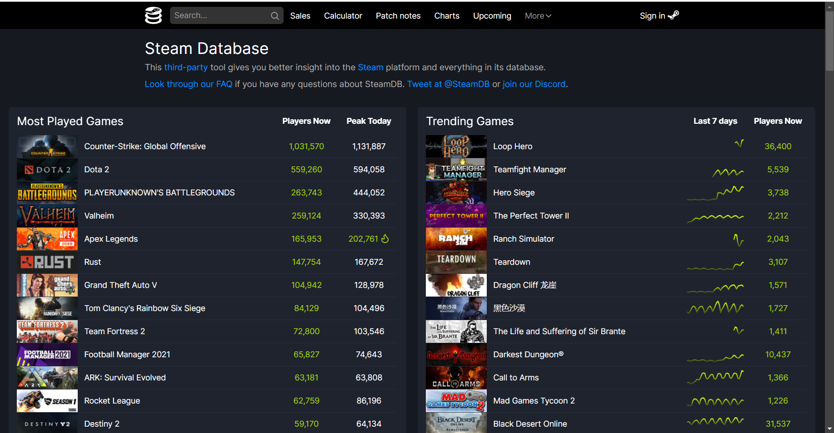

Figure 9 Reference Image Page: steamdb.info

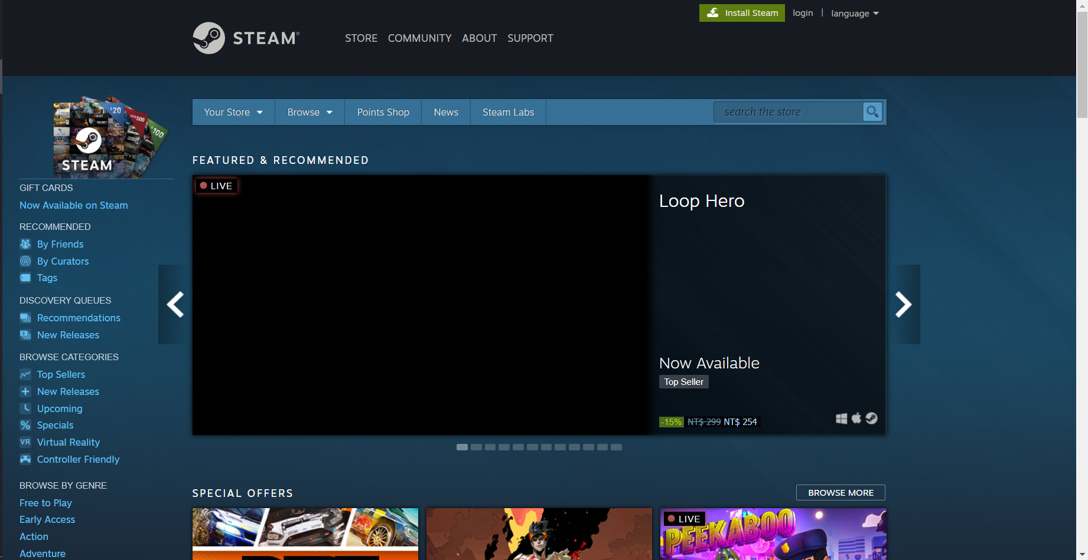

Figure 10 Reference Image Page: store.steampowered.com

**User Research Notes**

**Interview to Xiaohua Li (Game Nickname: Pillow)**

**Interviewer**: What games platform do you use the most often? What game do you play the most often, and where you purchased it?

**Respondent**: Steam, no doubt. I play various types of games, most of the game are purchased on steam and origin.

**Interviewer**: Do you think a price-comparison tool for video games on different platforms helps you, specifically when you are purchasing video games.

**Respondent**: Definitely it helps, I believe it also helps many other gamers when they are buying games. It helps me save money for the next brand new game. People’s needs to it will be inelastic.

**Interviewer**: What kinds of frame and structure do you expect for a price-comparison tool

**Respondent**: I think it must be user-friendly. It should be easy to use and concise. From my perspective, I expect it to be an extension tool that can attach to different game platforms or like a tiny digital dictionary that is convenient to look up. When I click on some buttons of this tool, it can immediately pump out the cheapest price of this game.

**Interviewer**: What kinds of examples can you give us for reference?

**Respondent**: Just like Grammarly, an extension tool that helps to correct people’s grammar. It is simple to use and associated with many websites and companies, such as Google.  Another example may be Oxford Dictionaries, it is a digital dictionary. that is very concise and easy to look up. You can just need to put it aside and use it in need.

**Interviewer**: Do you think that we should just focus on serval major game platforms?

**Respondent**: I think your target is right because the majority of people are using the hot game platform, such as steam. Some platforms are too small that can be really ignored.

**Interview to Zishu (Producer Nickname: Purple Math)**

**Interviewer**: What kinds of games have you produced and are currently making?

**Respondent**: Mobile Games. I publish games that are published on TapTap and Google play. I usually produce game works that are focusing on game play and design, and sometimes on its art works.

**Interviewer**: Who are your games’ main audiences?

**Respondent**: Usually students, college students, and workers who are just graduated or under thirty or thirty-five years old. I also do market research as well, finding out what kinds of game people are looking for.

**Interviewer**: As you’ve mentioned before, why sometimes focus on a game’s art design?

**Respondent**: Oh, it’s because that a delicate art design would cost a lot of money, and it's always hard to find artists who could provide art resources fitting your tastes. Therefore, I usually focus on game design, such as each level and the data and numerical design. (fyi, I used to be a numerical programmer)

**Interviewer**: Do you make your lives by producing **individual** games?

**Respondent**: Eer, not really. It is really hard to gain revenue by selling individual games, especially in China, as you’ve known. We used to provide in-game purchases and paid add-ons to make our lives. However, it doesn’t work so far, and the only way we can sell games is the game platform, Steam. However, it can be hard to publish one game on Steam and we have tradeoffs to do so.

Thus, I’m now making my own games, individuals games as a part-time interest, and make money by getting hired from a game company and working for them.

**Interviewer**: Last but not least, if there exists such a tool that could help you analyze the current game market and make a competitive pricing decision, would you prefer to utilize it?

**Respondent**: I would say, yes, and please develop such a tool. We, individual developers, are experts in designing games and producing games. However, we rarely know markets. We could cooperate with several huge publishers, but there’s tradeoff, we can rarely receive money from them, because most of the revenue would be taken from them. So, if there’s a tool that can help us to learn the market and decide our pricing or seasonal discounts for sale, I would be extremely grateful to use it.